Review_ CSA 2021

Chapter 9: Area
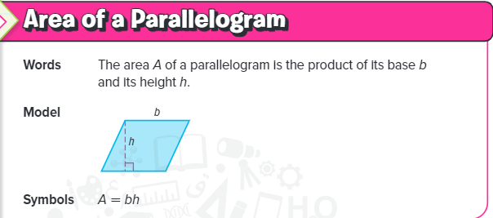
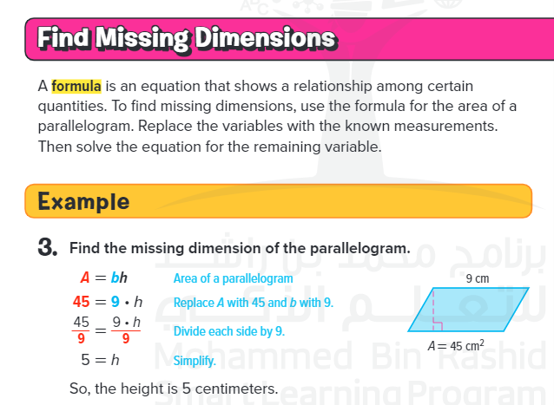

Review questions

- Find the area
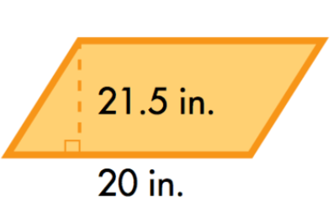
- 430 in²
- 215 in²
- 41.5 in²
- 1.5 in²

- When finding the area of a parallelogram, you should-

- When finding the area of a parallelogram, you should-
- Multiply the base and height, then divide by two
- Find the sum of the base and height
- Find the product of the base and height

- Find the area of a parallelogram with a base of 1.9 m and a height of 20 m
- 38 m
- 83 m²
- 3.8 m²
- 38 m²

- A _______________ is a quadrilateral with two sets of parallel sides.

- Trapezoid
- Parallelogram
- Kite
- Triangle

- Find the area of a parallelogram with a base of 30 m and a height of 25 m
- 750 m²
- 375 m²
- 705 m²
- 110 m²

- What is the area?
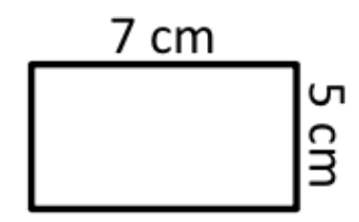
- 35 cm
- 30 cm
- 35 sq cm
- 12 cm
- Write the equation to solve for the Area of a Parallelogram. Then use it to find the missing dimension.
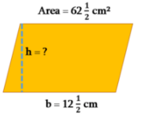
- 6cm
- 7cm
- 4cm
- 5cm

- Write the equation to solve for the Area of a Parallelogram. Then use it to find the missing dimension.
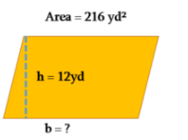
- 17yd
- 19yd
- 18yd
- 20yd

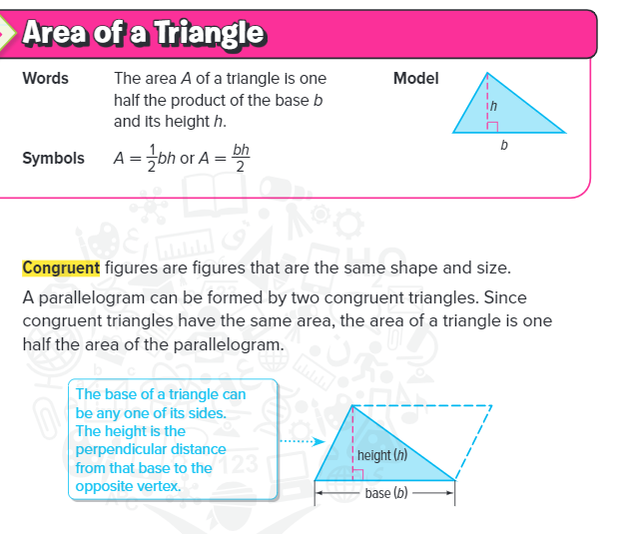
Review questions

- Find the area:
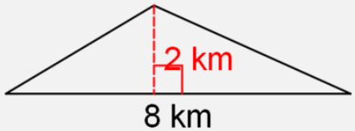
- 4 km²
- 16 km²
- 64 km²
- 8 km²

- Area of triangle?
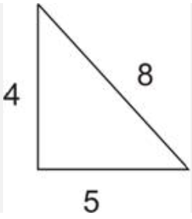
- 17 units²
- 20 units²
- 10 units²
- 16 units²

- Find the area of this triangle.
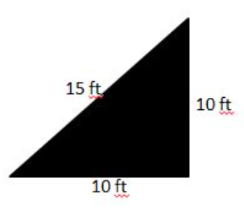
- 150 ft²
- 100 ft²
- 50 ft²
- 35 ft²

- Area?
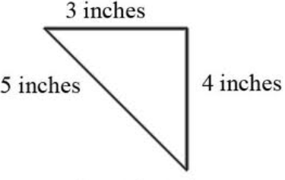
- 12 in sq
- 12 in
- 24 in sq
- 6 in sq

- Area or triangle?
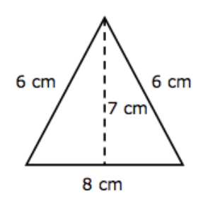
- 20 cm²
- 56 cm²
- 28 cm²
- 27 cm²

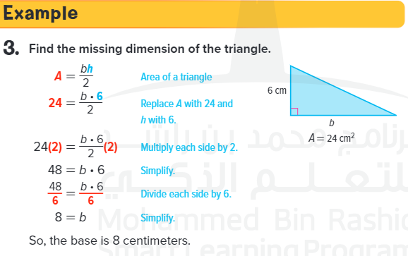

- Write the equation to solve for the Area of a Triangle. Then use it to find the missing dimension.
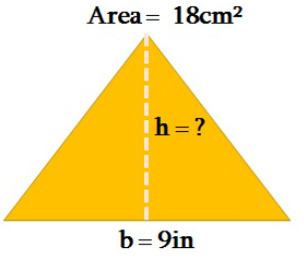
- 3in.
- 9in.
- 4in.
- 5in.

- Write the equation to solve for the Area of a Triangle. Then use it to find the missing dimension.
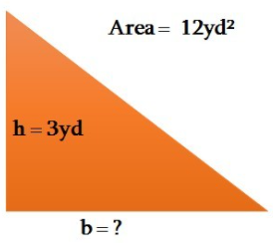
- 12yd.
- 3yd.
- 9yd
- 8yd

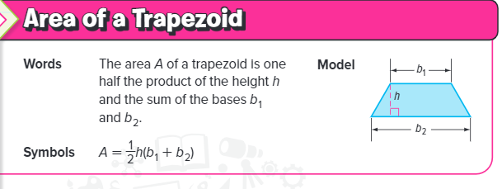
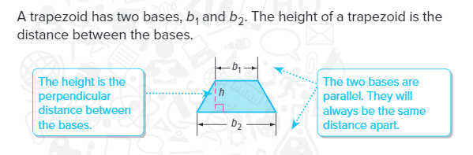
Review Questions

- What is the total length of the bases?
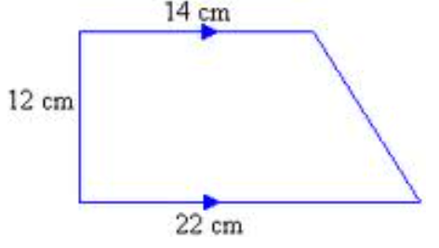
- 26 cm
- 34 cm
- 36 cm

- What is the height of this trapezoid?
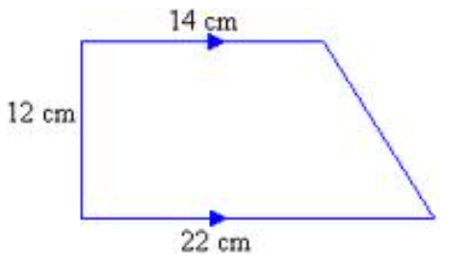
- 12 cm
- 14 cm
- 22 cm

- What is the area of this trapezoid?
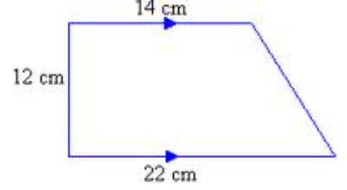
- 216 cm²
- 204 cm²
- 156 cm²
- What is the area of this trapezoid?
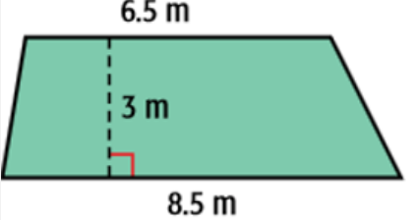
- 14.25 m²
- 17.25 m²
- 22.5 m²

- What is the area of this trapezoid?
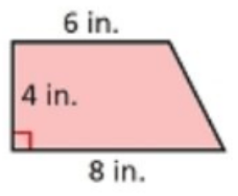
- 20 in²
- 24 in²
- 28 in²

- The trapezoid has an area of 108 square meters. Find the height.
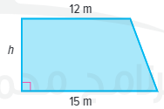
- 16
- 24
- 8
- 12

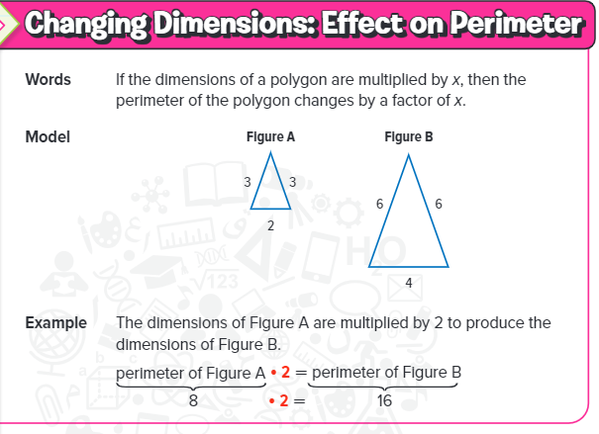

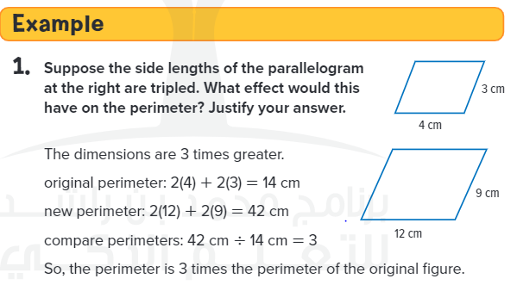

Review Questions

- What happens to the perimeter of a square if the sides are halved?
- Doubles
- Halved
- Quadrupled
- Forthed

- When multiplying by a scale factor the perimeter will multiply by...
- The same scale factor
- The scale factor doubled
- The scale factor squared (to the power of 2)

- A rectangle has a base 4 ft and height of 5 feet. If the figure dilated by a scale factor of 2, what will be true about its perimeter?
- The perimeter is doubled.
- The perimeter is quadrupled.
- The perimeter is two more.
- The perimeter is four more.

- A figure is multiplied by the scale factor 1/4. What will be the change in perimeter?
- The perimeter will be 1/4 the original perimeter.
- The perimeter will be 1/8 the original perimeter.
- The perimeter will be 1/16 the original perimeter

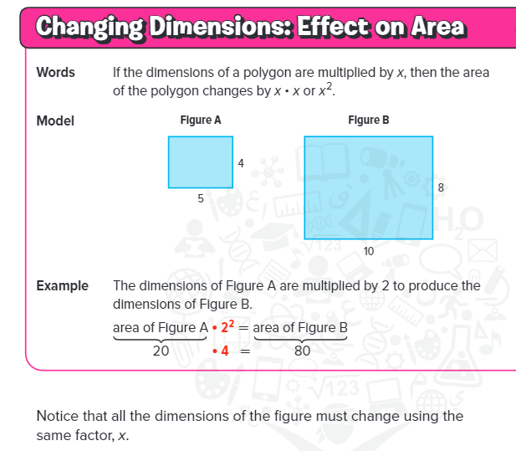
- If a rectangle is drawn and another rectangle is drawn so that the sides are twice as big as the first rectangle, what happens to the area?
- Doubles
- Triples
- Quadruples
- not enough information

- If a rectangle has an area of 48 cm², what would be the area of a similar rectangle if the dimensions are doubled?
- 96 cm²
- 192 cm²
- 216 cm²
- 2304 cm²

- A stop sign is in the shape of a regular octagon. Sign A shown at the right has an area of 310 square inches. What is the area of sign B?

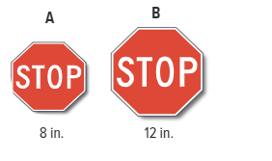
- 697.5
- 400
- 48

- The side lengths of the triangle at the right are multiplied by 5. What effect would this have on the area? Justify your answer.

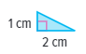

- 25 times bigger than original
- 5 times bigger than original
- 10 times bigger than original

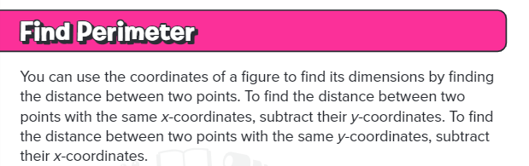

Review Questions

- A rectangle has vertices A (2, 8), B(7, 8), C(7, 5), and D(2, 5). Use the coordinates to find the length of each side. Then find the perimeter of the rectangle.

- 16 units
- 14 units
- 32 units
- 18 units

- Rectangle ABCD has vertices A(2, 1), B(2, 5), C(4, 5), and D(4, 1). Use the coordinates to find the length of each side. Then find the perimeter of the rectangle.

- 12 units
- 14 units
- 18 units
- 20 units

- Find the area of the figure in square units
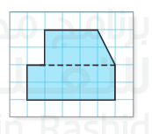
- 34
- 17
- 19
- 21

- A figure has vertices A(2, 5), B(2, 8), and C(5, 8). Graph the figure and then find the area.

- 4.5
- 9
- 18
- 36nm

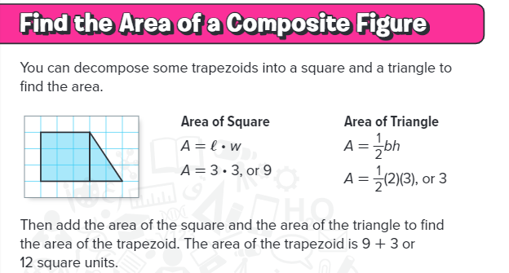
1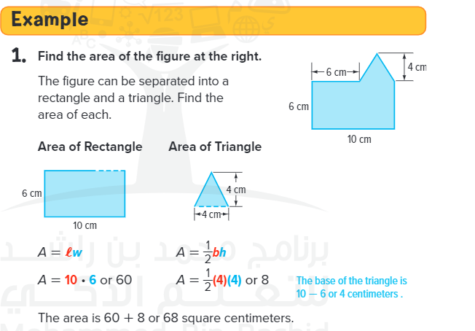

Review Questions

- What is the area of the shaded region?
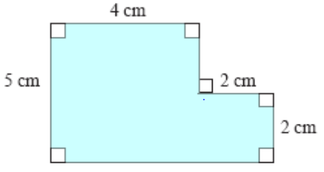
- 20 sq cm
- 4 sq cm
- 30 sq cm
- 24 sq cm

- What is the area of the composite figure?
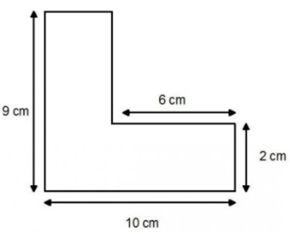
- 48 cm²
- 90 cm²
- 78 cm²
- 12 cm²

- Find the area of the composite figure
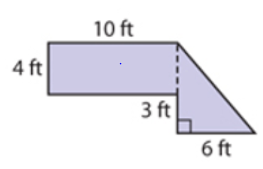
- 40
- 9
- 49
- 61

- What is the area of the figure?
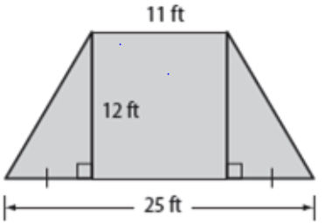
- 48 ft2
- 216 ft2
- 65 ft2
- 128 ft2

- Find the area of the figure shown.
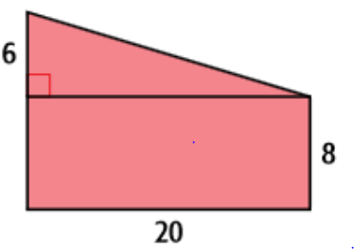
- 34 units²
- 960 units²
- 220 units²
- 480 units²

- Find the area of the figure.
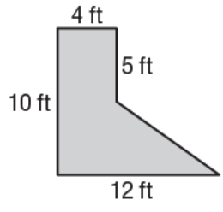
- 31 ft²
- 40 ft²
- 60 ft²
- 80 ft²

- What is the area of the composite shape?
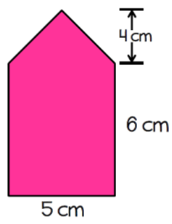
- 50cm²
- 25cm²
- 40cm²
- 35cm²

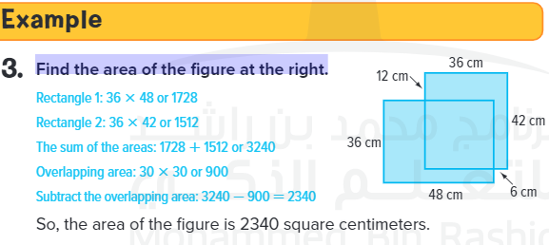

- Find the area of the figure:

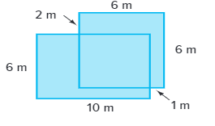
- 65
- 75
- 100
- 90

