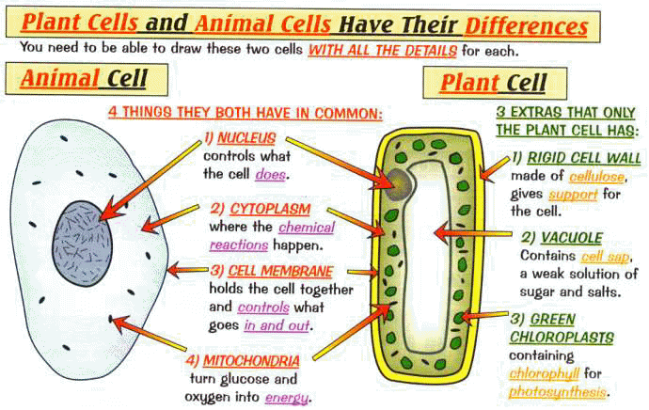
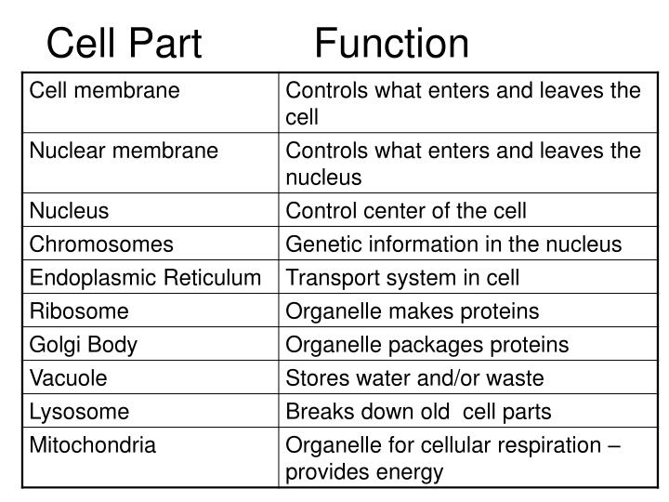

- What is the smallest unit of all living things?
- Cell b. organ c. organelle d. tissue

- Which of organelles store water, carbohydrates, and wastes in plants
- Chloroplast b. mitochondrion c. nuclei d. vacuoles

- What is a rigid structure that provides support and protection to plants and some types of bacteria
- Chloroplast b. nucleus c. cell membrane d. cell wall

- What are cells mostly made of?
- DNA b. lipids c. proteins d. water

- Which cell structures break down food and release energy
- Chloroplast b. mitochondrion c. ribosomes d. vacuoles

- Which cell structures packages proteins into vesicle?
- Central vacuoles b. endoplasmic reticulum c. Golgi body d. nuclear envelope

- Which is an organelle in plant cells but not in animal cells?
- Chlorophyll b. chloroplast c. mitochondrion d. nucleus

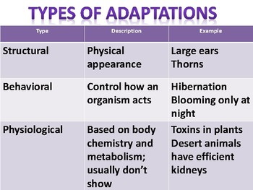
Adaptation is an inherited trait that helps a species survive in its environment
Variation: is a slight difference in inherited traits among individual members of a species.
VARIATION IN ANIMALS
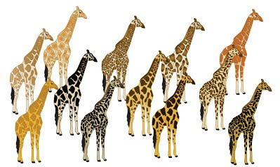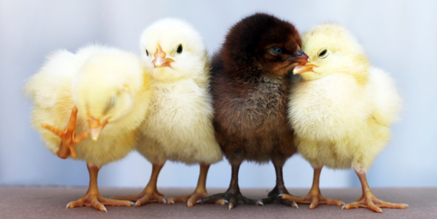

Natural Selection : is the process by which organisms with variations that help them survive in their environment live longer, compete better and reproduce more than those that do not have variations.
Selective breeding : is the selection and breeding of organism with desired traits. Selective breeding is similar to natural selection except HUMANS do the selection instead of NATURE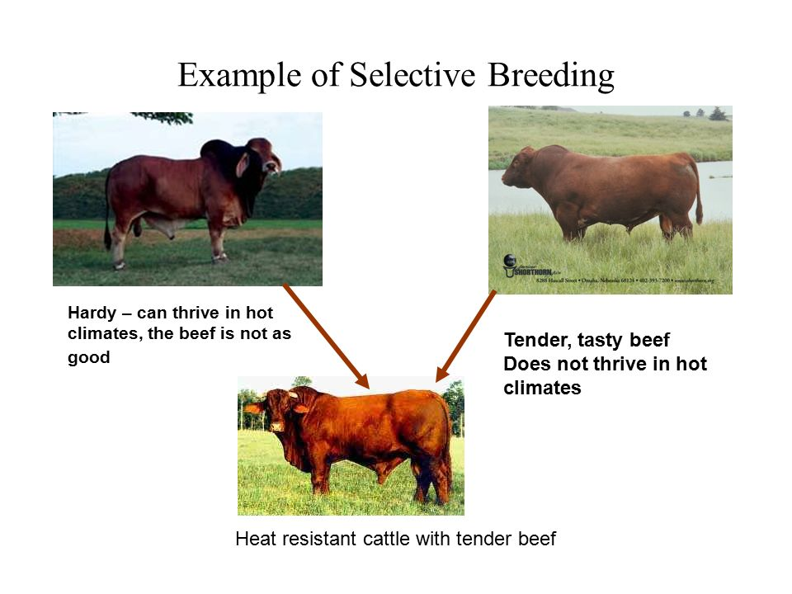
Mimicry is an adaptation in which one species looks like another species.
Camouflage is an adaptation that enables a species to blend in with its environment

- A non-poisonous butterfly has coloration and markings similar to poisonous butterfly. This is an example of
- Camouflage b. mimicry c. behavioral adaptation d. functional adaptation

- Which statement about mutations is NOT true?
- Genes in any cell type can mutate
- Most mutations are harmful
- Most mutations occur randomly
- Some mutations help organisms survive

- The giraffe’s long neck helps this species reach food that animals with short necks cannot reach. What type of adaptation is the long neck?
- Behavioral b. biochemical c. functional d. structural

- Which is a source of variation?
- Adaptation b. mutation c. phenotype d. traits

- Which adaptation is functional?
- A lizard playing dead b. a monkey swinging by its tail c. a skunk spraying a predator d. a wolf hunting in a pack

- Giraffe range in color from orange to yellow. Which explains these color differences
- Adaptations b. variations c. natural selection d. selective breeding

- Which is the sequence by which natural selection works?
- Selection -------------adaptation -----------------variation
- Selection-------------variation--------------------adaptation
- Variation--------------adaptation-----------------selection
- Variation--------------selection------------------adaptation

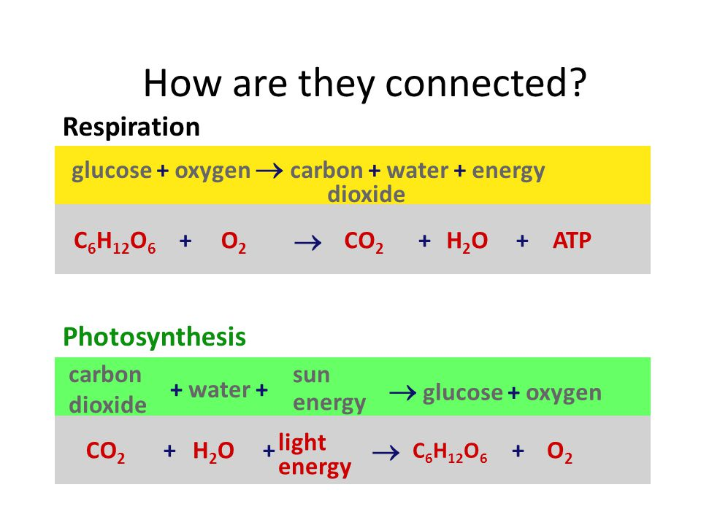

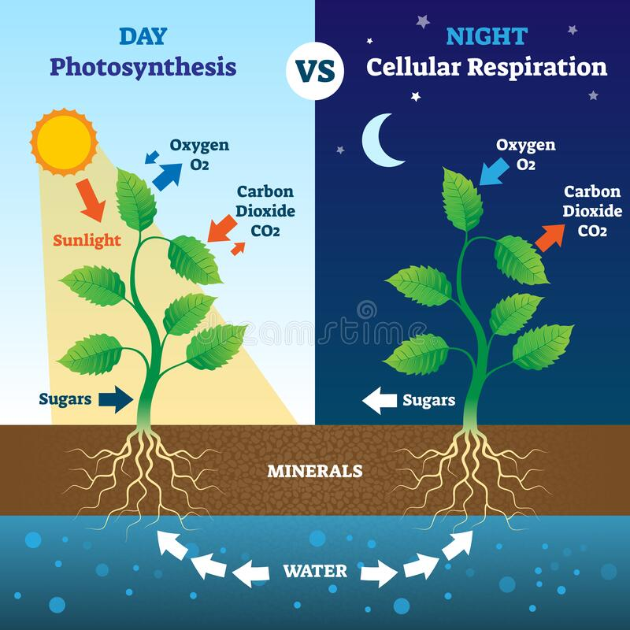

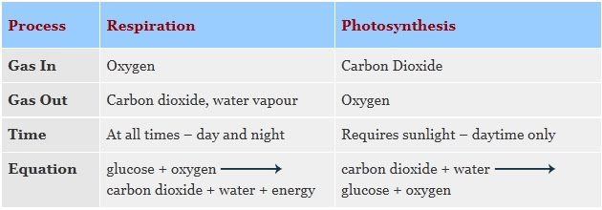
- During which process are carbon dioxide , water and ATP (ENERGY ) produced
- Cellular respiration b. photosynthesis c. thigmotropism d. transpiration

- Which is the cause of green color in plant leaves?
- Chlorophyll b. flowers c. glucose d. oxygen

- What is the major site of photosynthesis?
- Flowers b. leaves c. stems d. roots

- Which is true of photosynthesis and cellular respiration?
- They both occur in plants b. they both occur in animals c. they both produce sugar d. They both require sunlight.

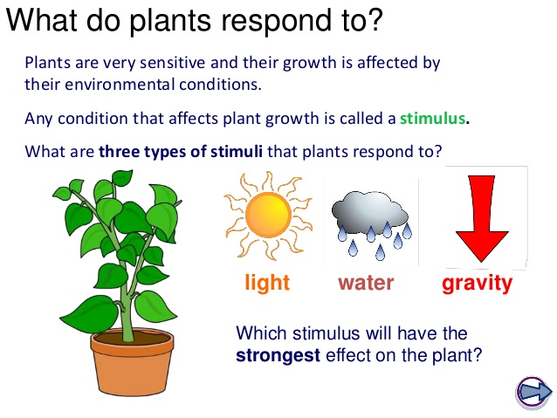
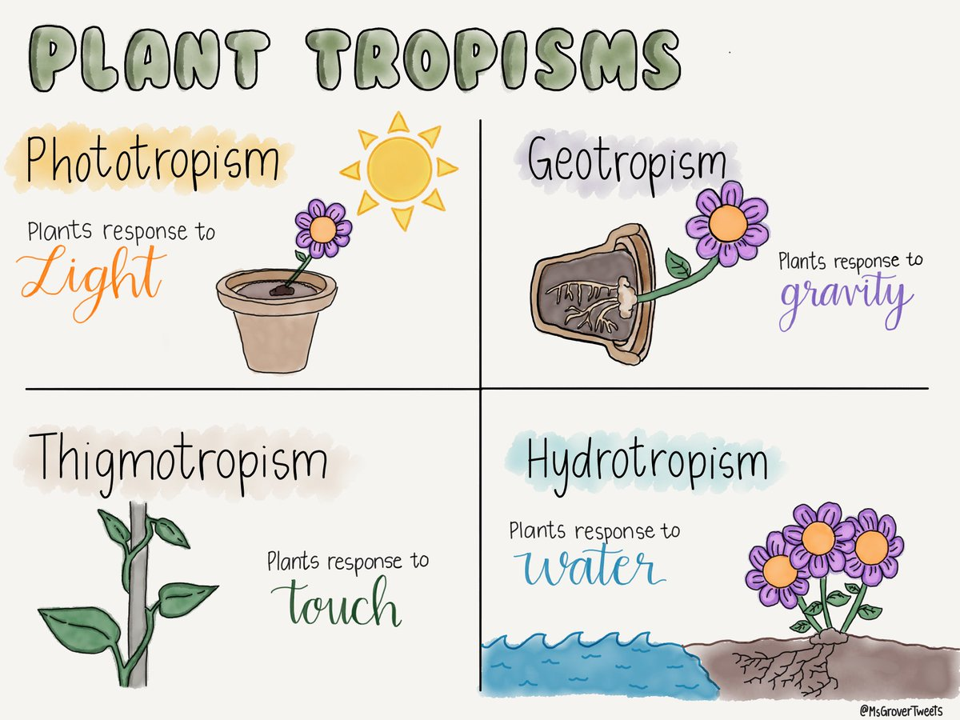
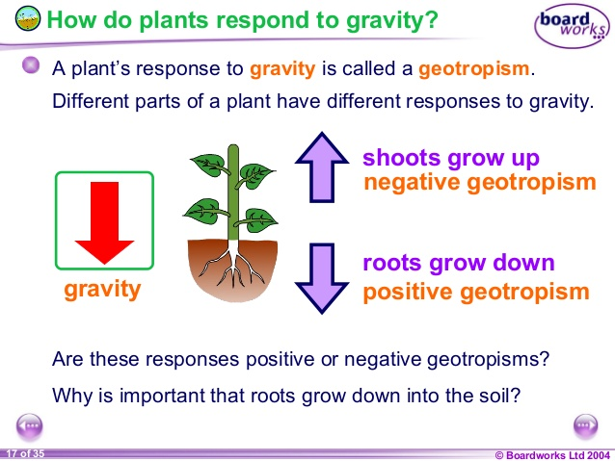
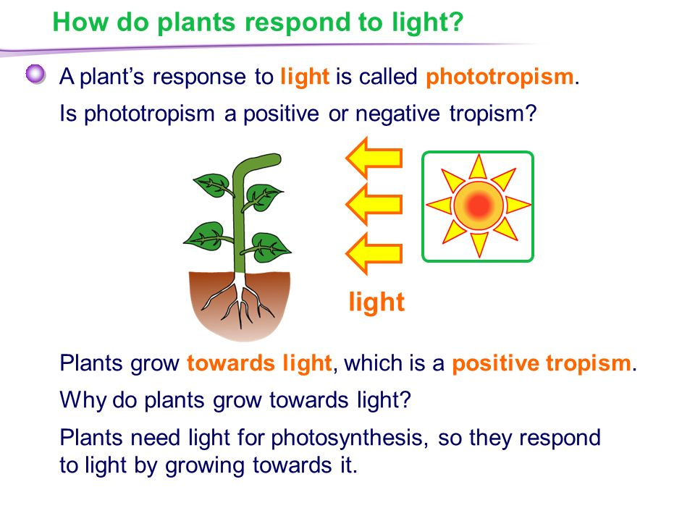
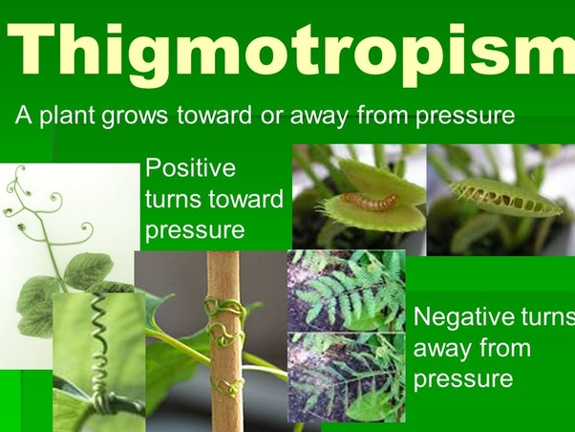
- A plant that is growing toward a window most likely is exhibiting
- Gravitropism b. hydrotropism c. phototropism d. thigmotropism

- Any change in an organism’s environment that cause a response is called
- Photosynthesis b. cellular respiration b. stimuli d. tropism

- Example of external stimuli is
- Hormones b. light c. feeling hot d, feeling cold
4. This example is for

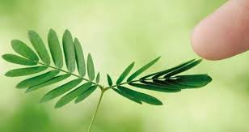 a. phototropism b. hydrotropism c. thigmotropism d. gravitropism

- The roots have negative
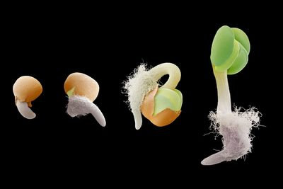 a. phototropism b. hydrotropism c. thigmotropism d. gravitropism

- Internal stimuli are chemicals called -----------------that a plant produces
- Light b. water c. Hormones d. Gravity

- This example is for
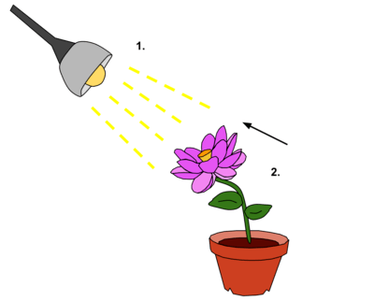a. internal stimuli b. light stimuli c. temperature stimuli

