REVIEW FOR EXAM ON 31ST MAY

11.2 Cells

**1. What is cell made up of?**

Ans. 1 Cells are made up of four macromolecules known as nucleic acids, lipids, proteins, and carbohydrates.

**2. How do the parts of a cell enable it to survive?**

Ans.2 Cells have different organelles, which helps it to survive.

**3. Water, proteins and other substances are found in the _________________ of a cell.**

Ans.3 Cytoplasm.

**4. Define mitochondrion in your own words**.

Ans. 4 The mitochondrion is an organelle found in animal and plant cells; it is used to process energy.

**5. Which organelles store water, carbohydrates and wastes in plants?**

a. Chloroplast

b. Mitochondria

c. nuclei

d. vacuoles

**6. Compare how energy is processed in animal and plant cells.**

Ans. Plant cells contain chloroplasts that convert the energy from sunlight into ATP and carbohydrates, whereas animal cells use mitochondria to convert nutrients into ATP.

**7. Distinguish between a cell membrane and a cell wall.**

**Ans** The cell membrane surrounds all cell types. However, cell walls are found in plants and some bacteria on the outside of the cell membrane. Both structures provide protection, but the cell wall is more rigid than the cell membrane.

**8. Summarize use the table below to identify organelles and their functions.**

|  |  |
| --- | --- |
| **Organelle** | **Function** |
| Nucleus | Controlling Cell activities |
| Mitochondria/Chloroplast | Energy Processing |
| Vacuole | Storage |

**9. Assess the role of water in cell function.**

Ans. Water dissolves ions and other substances and helps substances and organelles move around in cells.

**10. Relate the cell wall to protection in bacteria.**

Ans. Cell walls are rigid structures that prevent toxins and other substances from being taken up by cell membranes.

**11. What is a rigid structure that provides support and protection to plants and some types of bacteria?**

A. chloroplast

B. nucleus

C. cell membrane

D**.** cell wall

**12. Which organelle is the arrow pointing to in the picture below?**

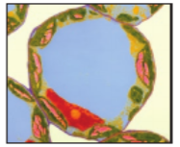

A. chloroplast

B. cytoplasm

C. mitochondrion

D**. vacuole**

13. Which is NOT a characteristic of all living things?

A. grow

B. reproduce

C. have organelles

D. use energy

14. Which organelle is the arrow pointing to in the picture below?

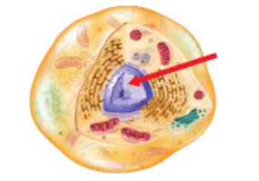

A. chloroplast

B. cytoplasm

C. mitochondrion

D. nucleus

15. What is the smallest unit of all living things?

A. cell

B. organ

C. organelle

D. tissue

16. What are cells mostly made of?

A. DNA

B. lipids

C. proteins

D. water

18. **The diagram shows the parts of a plant cell. What is the name and function of structure A?**

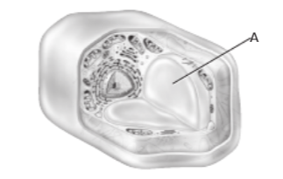

A chloroplast, making carbohydrates

B chloroplast, producing energy

C vacuole, storing water

D vacuole, transporting proteins

**19. Which molecule stores energy for cells?**

A ATP

B DNA

C proteins

D ribosome

**20. In the diagram, the organelle labeled A packages proteins into vesicles. What is this organelle called?**

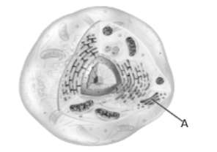

A central vacuole

B endoplasmic reticulum

C Golgi apparatus

D nuclear envelope

**21Which cell structures break down food and release energy?**

A chloroplasts

B mitochrondria

C ribosomes

D vacuoles

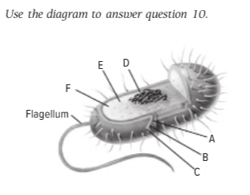

In the cell shown, what is the letter for the structure that provides much of the cell’s support and helps protect it from outside environment.

A. A

B. B

C. C

D.D

**12.2 Adaptations in Species**

**Explain how mutations causes variation**

Giraffe spots were probably the **result of a mutation** that occurred in an individual giraffe many generations ago. The mutation produced a variation that helped the giraffe survive.

So we can say that Adaptation occur due to mutations which cause variation and then because of natural selection it becomes permanent.

If a variation helps an organism survive or compete better in its environment, the organism with that variation lives longer. Because it lives longer, it has more offspring that also can have the variation. Over many generations, more and more offspring inherit the variation. Eventually, most of the population has the variation, and it becomes an adaptation, as shown in Figure 9. Because mutations are random and occur continually, so do new variations. The variations that become adaptations depend on the environment. Over time, all environments change. Huge volcanic eruptions can change a climate rapidly. The movement of continents causes slow, gradual changes. When an environment changes, a population either adapts through natural selection or dies off. The repeated elimination of populations can lead to the extinction of a species.

- identify and explain the types of adaptations



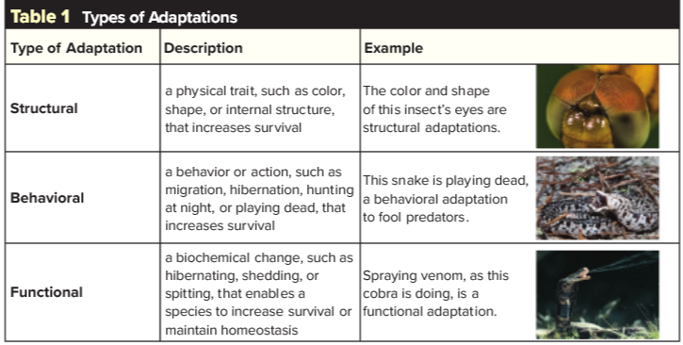

1. A nonpoisonous butterfly has coloration and markings similar to a poisonous butterfly. This an example of

A. camouflage.

B**. mimicry.**

C. behavioral adaptation.

D. functional adaptation.

2. Which is a source of variations?

A. adaptations

B. **mutations**

C. phenotype

D. traits

3. Which is the sequence by which natural selection works?

A. selection → adaptation → variation

B. selection → variation → adaptation

C. variation → adaptation → selection

D. **variation → selection → adaptation**

4. Which adaptation is functional?

A. a lizard playing dead

B. a monkey swinging by its tail

C. **a skunk spraying a predator**

D. a wolf hunting in a pack

5. Which process is illustrated below?

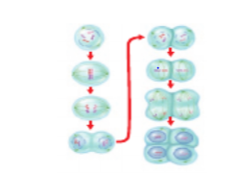

A**. meiosis**

B. mutation

C. asexual reproduction

D. natural selection

6. Giraffes range in color from orange to yellow. Which explains these color differences?

A. adaptations

B. **variations**

C. natural selection

D. selective breeding

**7.** Which explains how variations arise within a population of organisms?

A asexual reproduction

B behavioral adaptation

C natural selection

D **random mutation**

8. The photo below is a leaf butterfly. Which explains how the butterfly came to resemble

a leaf?

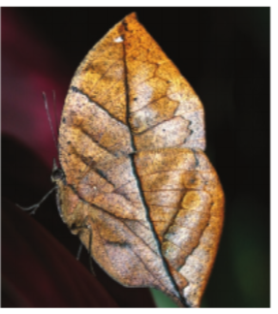

A. The butterfly’s shape is the result of an exchange of genes with plants over many generations.

B. The butterfly’s shape is the result of the environment causing mutations over many generations.

C. The butterfly’s shape is the result of the environment influencing its phenotype over many generations.

D. **The butterfly’s shape is the result of the environment selecting variations over many generations.**

9. The sunflower plants shown are the same species.

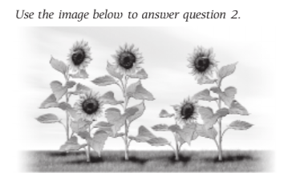

The differences in height among the plants is an example of

A adaptation.

B fertilization.

C population.

D **variation**

10. Which results from the interaction of genes and environment?

A genotype

B **phenotype**

C chromosome number

D sequence of DNA

11. Use the image below to answer question 11.

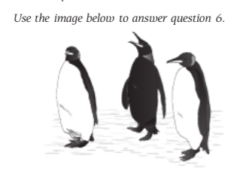

Feather color is an inherited trait in penguins. What most likely caused the differences shown?

A change in environment

**B DNA sequence error**

C physical factor

D social factor

12. Which statement about mutations is NOT true?

A Genes in any cell type can mutate.

B **Most mutations are harmful.**

C Most mutations occur randomly.

D Some mutations help organisms survive

13. The giraffe’s long neck helps this species reach food that animals with short necks cannot reach. What type of adaptation is the long neck?

A behavioral adaptation

B biochemical adaptation

C functional adaptation

D **structural adaptation**

Use the diagram below to answer question 14.

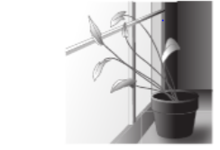

15. The plant shown above is responding to light in its environment. This is an example of

**A an adaptation**.

B a population.

C selection.

D variation.

16 Which describes a mutation?

A **a change in a gene’s DNA sequence**

B a trait that helps a species survive

C a change due to an environmental factor

D a distinguishing inherited characteristic

1. Plant growth towards or away from a stimulus is called ____________________

Answer- Tropism

1. A plant that is growing towards window most likely is exhibiting.
2. Gravitropism
3. Hydrotropism
4. Phototropism
5. Thigmotropism
6. During which process are carbon dioxide, water and ATP produced?
7. Cellular respiration
8. Photosynthesis
9. Thigmotropism
10. Transpiration
11. Which is the cause of the green color in plant leaves?
12. Chlorophyll
13. Flowers
14. Glucose
15. Oxygen
16. Which is NOT a product of cellular respiration?
17. Energy
18. Glucose
19. Oxygen
20. Water
21. Which is true of photosynthesis and cellular respiration?
22. They both occur in plants.
23. They both occur in animals.
24. They both produce sugars.
25. They both require sunlight.
26. What term describes the plant response shown above?

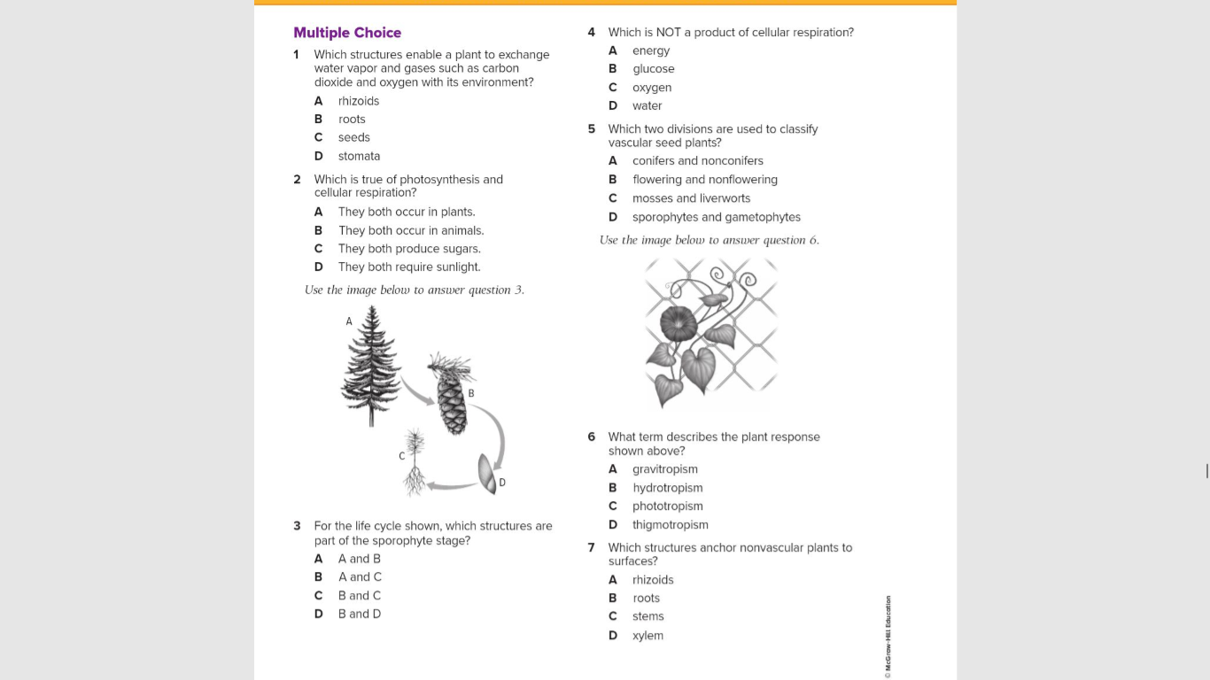

1. Gravitropism
2. Hydrotropism
3. Phototropism
4. Thigmotropism